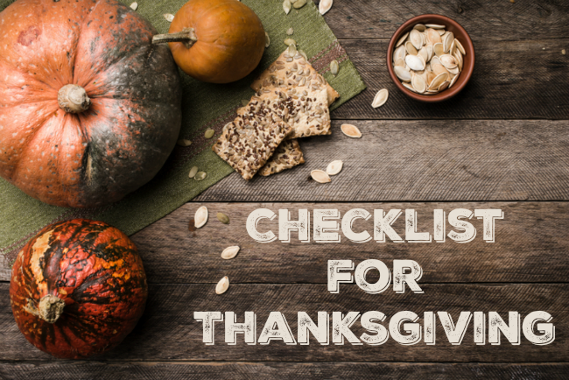
 | Turkey |  | Relish (D)
 | Turkey Giblets, Liver, Heart, Gizzard (S) |  | Mustard (D)
 | Chunk Pepperoni (S) |  | Balsamic Glaze (B)
 |  |  | Mayonnaise (SD)
 | Potatoes (M)
 | Sweet Potatoes |  | Butter (M)
 | Cranberries |  | Goat cheese (B)
 | Lemon (for water) |  | Cream cheese (P) (M)
 | Sage (S) |  | Eggs (D)
 | Thyme (S) |  | Sharp Cheddar (A)
 | Garlic (S) |  | Sour Cream (SD)
 | Celery Ribs (S) |  | Milk (G)
 | Onion (S) |  | Coffee Creamer
 | Brussel Sprouts (B) |  | Heavy whipping cream
 | Granny Smith Apples (A) |  | Half-and-half
 | Green Onion (SD) |  | Small curd cottage cheese (P)
 | Green Beans (G) |  | Cool-Whip (P)
 | Canned Mandarin Oranges (P) |  | Frozen Spinach (SD)
 | Canned chipotle peppers in adobo sauce (D) |  | Pie crust
 | Canned Crushed Pineapple (P)
 | Water Chestnuts (SD) |  | All-purpose flour
 | Canned yams |  | Black pepper (S) (G) (M)
 | Cream of Mushroom Soup (G) |  | Kosher salt (S) (G) (M)
 |  |  | Vanilla extract
 | Round loaf pumpernickel (SD) |  | White vinegar
 | Stale Italian Bread (2 Loafs) (S) |  | Wondra for Gravy
 | Dinner Rolls |  | Cinnamon (A)
 |  |  | Sugar (A)
 | Chicken/Turkey broth (S) |  | Brown sugar
 | Vegetable Soup Mix (SD) |  | Olive Oil (S)
 | Fried Onions (G) |  | Pumpkin Puree
 | Soy Sauce (G) |  | Pumpkin Pie Spice
 | Crackers (A)
 | Strawberry Jell-O (P)
 | Coffee |  | Apple Cider
 | Wine |  | Compliments of http://lifewithlisa.com

